Gosport Community Safety Partnership
Strategic Plan 2018 – 2019

Introduction
Gosport is an urban peninsula situated on the Solent coastline located between the cities of Portsmouth and Southampton with the population of Gosport being 85,363 (Office for National Statistics, 2016). Gosport Community Safety Partnership (CSP) brings together partners from a range of statutory and non-statutory organisations that are committed to ensuring the safety of Gosport communities by addressing and reducing crime and anti-social behaviour (ASB). Through analysis of crime data and intelligence the Partnership has identified three priority areas which will inform the key areas of work for the 2018 – 2019 financial year.
Vision and Strategic Priorities
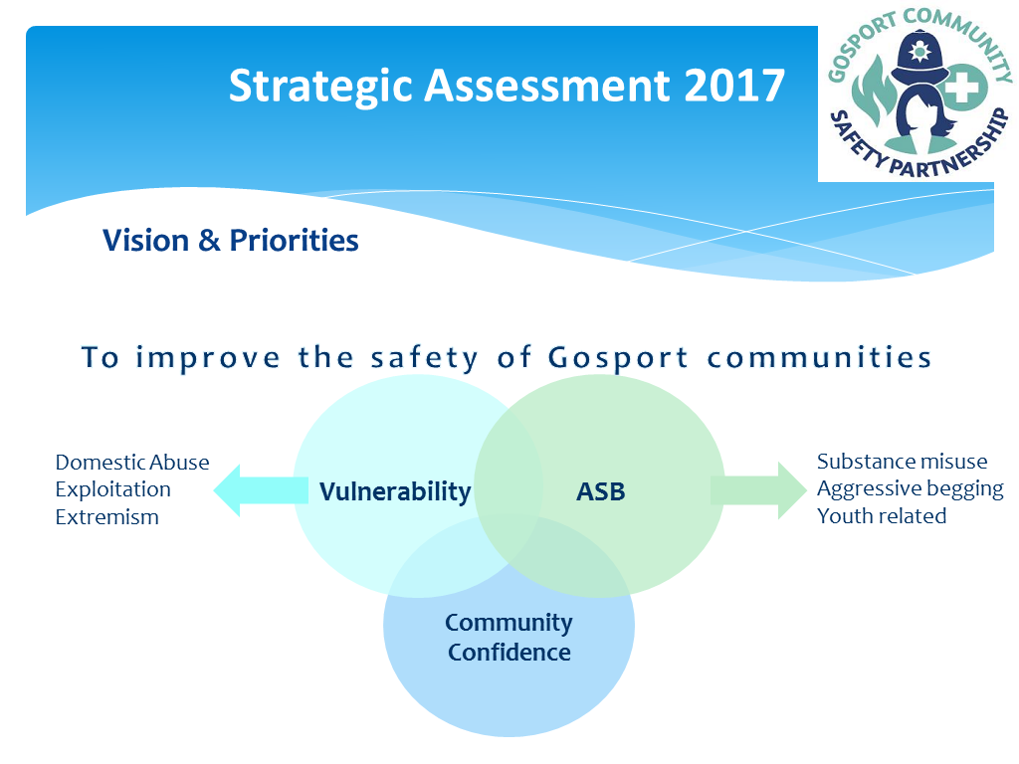
Nationally police recorded crime has increased by 10% (Office for National Statistics, 2017) and this trend is reflected within Hampshire, with Gosport also seeing an increase in most crime types. Increasing crime levels are corresponding with fewer resources and growing demand from high risk issues.
Strategic Priority 1 – Vulnerability
Why is it a priority?
Nationally and locally it is increasingly recognised that serious and organised crime impact on our communities. The exploitation of young people and vulnerable adults, which may be categorised as county lines, cuckooing and modern slavery, is increasing in volume and complexity both nationally and within Hampshire. Consequently, there is the need to ensure that communities are better at spotting the signs of exploitation whilst continuing to focus on the threat of extremism because of the potential level of harm caused. Domestic abuse accounts for 13% of all crime within Hampshire and within Gosport. Whilst there are improvements in recording it remains under-reported and Gosport has been identified as an emerging risk by the force. The community survey undertaken at the Safer Gosport Community Day 2017 indicated that ‘protecting vulnerable people’ should be a key priority for the CSP.

Strategic Priority 2 – ASB
Why is it a priority?
Anti-social behaviour continues to impact on communities’ quality of life as well as their confidence in the police and partners. In Gosport ASB is presenting primarily as substance misuse & aggressive begging as well as reports of young people committing ASB. Nationally there is significant increase in rough sleeping which is reflected locally and there are links to reports of street-related ASB such as begging. Gosport residents surveyed at the past two Safer Gosport Community Days have reported that ASB associated with rough sleeping was a visible issue. Youth-related ASB continues to be highlighted as an issue within Gosport and can be associated with high deprivation levels as well as poor academic achievement s.

Strategic Priority 3 – Community Confidence
Why is it a priority?
Of those surveyed at the Safer Gosport Community Day 2018, 71% of respondent s ‘feel safe in Gosport’ compared to 83% in 2017 and 93% in 2016. Whilst the number surveyed is low this provides an indication that community confidence may be decreasing. There are potentially several reasons for this, but studies suggest the public are increasingly aware of the demands on public services including the police. Substance misuse and youth related ASB are increasingly visible and the rise in police recorded crime has been regularly reported in the media which intensifies the fear of crime.
Action Plan – How will the CSP improve the Safety of Gosport Communities?
Strategic Priority | Description | Action | Action Owner | Date
Vulnerability | Domestic Abuse | Support partnership referrals to MARAC by promoting the use of the DASH (Domestic Abuse, Stalking and Honour-based violence) risk identification checklist. | Community Safety Officer |  | March 2019
 | Domestic Abuse | Deliver an event to mark International Day for the Elimination of Violence against Women to raise awareness of all types of Domestic Abuse. | Community Safety Officer |  | November 2019
 | Exploitation | Publicise the information and resources available on the Safe4Me website https://www.safe4me.co.uk/ to a wide-ranging audience. | Community Engagement & Project Officer |  | March 2019
 | Exploitation | Support the delivery of the Modern Slavery Partnership Strategy by raising awareness of this crime and how to report it. | Community Engagement & Project Officer |  | March 2019
 | Extremism | Actively promote the availability of Third Party Reporting Centres within Gosport to support victims and to increase the intelligence picture in relation to hate crime and extremism. | Community Engagement & Project Officer
 | Extremism | Improve awareness of Prevent by promoting the Hampshire PREVENT Partnership Board Website http://www.hampshirepreventboard.org.uk/ | Community Engagement & Project Officer |  | March 2019
ASB | All ASB | Co-ordinate multi-agency support and enforcement to assist with vulnerable individuals, persistent offenders and problematic locations through partner referrals made to the Partnership Action Group. | Community Safety Officer |  | March 2019
 | All ASB | Continue to develop the use of the mediation service delivered by the Community Safety Team to support demand reduction to front line services. | Community Engagement & Project Officer |  | March 2019
 | Youth related | Prevent young people from entering the criminal justice system by the early management of ASB through the use of ASB warning letters, ABCs, Civil Injunctions and identifying potential nominations for the DIVERT programme. | Community Safety Officer |  | March 2019
 | Youth related | Deliver and continue to develop the successful Summer Passport Scheme which offers positive diversionary activities for young people of secondary school age. | Community Engagement & Project Officer |  | August 2018
 | Youth related | Ensure co-ordinated support is provided through the Supporting Families Programme for young people and families referred to the Early Help Hub (EHH) and PAG. | Community Safety Officer |  | March 2019
 | Substance Misuse | Lead the co-ordination of the Homelessness Action Group to make Gosport a safer place by providing support for those who are street homeless and to address problematic street activity such as begging and substance misuse. | Community Safety Officer |  | March 2019
 | Substance Misuse | Work with partners to support the delivery of a media campaign in conjunction with Alcohol Awareness Week to get people to understand how alcohol affects society as a whole. | Community Engagement & Project Officer |  | November 2018
Community Confidence | Promote existing services available for those who are street homeless within Gosport to members of the public and develop a co-ordinated approach to identify a long-term solution for individuals. |  | Community Safety Officer |  | March 2019
 | Utilise Gosport’s Cycle Safe initiative to work in partnership to engage communities to promote personal cycle safety and cyclists’ responsibilities. |  | Community Safety Officer |  | March 2019
 | Deliver a YOU Decide participatory budgeting event to assist with improving services for young people in Gosport. |  | Community Engagement & Project Officer |  | March 2019
 | Delivery of the annual Safer Gosport Community Day which proactively connects with our communities and gives members of the public the opportunity to engage with key community safety stakeholders. |  | Community Engagement & Project Officer |  | March 2019
 | Promote Hampshire Alerts Community Messaging system to assist with improving the information flow between the community and the police which is vital to keeping our communities safer. |  | Community Engagement & Project Officer |  | March 2019

How will we monitor our impact?
Gosport CSP Plan sets out the vision, strategic objectives and actions which will be delivered throughout 2018/19. Within Gosport there is a history of strong partnership working and successful delivery of this plan will be dependent on partners proactively supporting delivery of the actions outlined. Progress against this plan will be monitored throughout the financial year through the use of a performance management system with a formal review of partnership delivery being undertaken at the bi-annual CSP Board.

