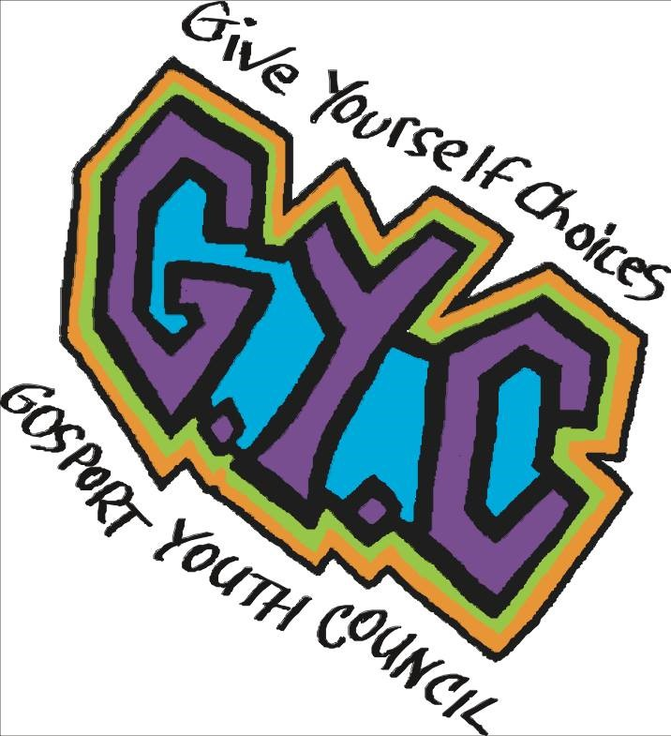

Gosport Youth Council

2016 Careers Conference report

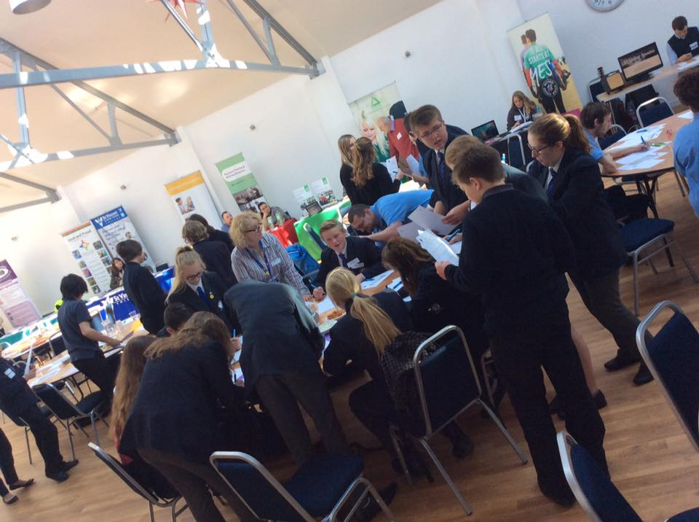

***Contents***

|  |  |
| --- | --- |
| Foreword | 3 |
| Introduction | 3 |
| Theme | 3 |
| Aims | 3 |
| Objectives | 3 |
| Philosophy | 4 |
| Programme of Events | 4 |
| Room layout and Organisations | 5 |
| CV Writing & Transferable Skills | 6 |
| Barclays Life Skills | 6 |
| Voluntary Work | 7 |
| Success Stories | 7 |
| Questions and Answer Session | 8 |
| Other Activities | 8 |
| Summary and Evaluation | 8 |
| Conclusion and Recommendations | 9 |
| Appendices | 10 |
| * Mapping Exercise | 10 |
| * CV Writing and Transferable Skills responses | 13 |
| * Barclays Life Skill responses | 15 |
| * Wall questions | 16 |
| * + Where do you get your careers advice from? | 16 |
| * + Who inspires you? | 16 |
| * + What career do you think you can aspire to? | 17 |
| * + What do you see yourself doing in 5 years’ time? | 17 |
| * + What is your biggest concern about the topic of careers? | 18 |
| * + If you could do one thing to improve Gosport, what would it be? | 18 |
| Feedback Results | 19 |
| Survey Results | 25 |

**Gosport Youth Council would like to thank the following for supporting the 2016 Careers Conference:**

Gosport Borough Council

Cllr Mark Hook

Cllr Maggie Morgan

Sam Mitchell

Caroline Dinenage MP

Lucy Burton

St Vincent

Lynbyrd Express

National Citizen Service

Gosport Voluntary Action

Groundwork

Stuart Lovibond

Natasha Hook

Nick Caspar

David Thomson

Leon’s Fruit and Veg

Moorhouse Sweets

Rebecca Stares

Stallholders

Bay House

Bridgemary School

Brune Park

Motiv8

***Foreword***

Gosport Youth Council decided to host a Youth Conference for young people in Gosport to try and get young people’s opinions, views and to educate young people to try to gain new members.

Previously Gosport Youth Council have held an annual conference however this has not occurred since 2012. In recent years the funding for Youth Council’s has disappeared. In 2013 GYC were no longer funded by Y Services and moved under the umbrella of Gosport Borough Council. Due to funding cuts by government the funding we receive is very limited meaning that it is difficult for us to undertake projects such as those mentioned in the previous page. The Local Children’s Partnership has also ceased to function in the same capacity as previously and all of these factors have contributed to a huge loss in funding and support for the GYC. This 2016 Careers Conference is hoped to re start the annual Gosport Youth Council conferences.

***Introduction***

The Gosport Youth Council 2016 Careers Conference took place at the Jervis Gallery, St Vincent, Gosport on Thursday 14 April. Every secondary school, college and other educational establishments in Gosport were invited to attend. Students from Bay House, Bridgemary, Brune Park and Motiv8 attended the day together with the members of Gosport Youth Council.

The event was planned by members of the Gosport Youth Council in conjunction with Sam Mitchell, Community Engagement and Projects Officer, Gosport Borough Council, Cllr Maggie Morgan, Youth Champion, Gosport Borough Council and Natasha Hook, Administrative Officer to Caroline Dinenage MP.

The workshops were led by outside facilitators such as Lynbyrd Express and other organisations as well as being introduced and supported by members of Gosport Youth Council.

***Theme***

The theme of the event was decided following on from a “Gosport Youth Council – We Want Your Views” survey, which was conducted in December 2015. The results from this showed that that top three issues for Young People in Gosport were crime, bullying and career opportunities.

The Gosport Youth Council members decided that we should do a careers conference to try and improve this aspect, and other projects surrounding bullying and crime.

***Aims***

* To improve the outlook on careers.
* To educate young people on what they can do to help their career prospects.
* To provide advice on what they can do to improve their career prospects.
* To engage local companies/organisations with young people.
* To minimize career opportunities as a top issue for young people in Gosport.

***Objectives***

* To share and educate young people on career opportunities and the opportunities they have.
* To consult with young people through meaningful engagement opportunities.
* To give young people the opportunity to share their thoughts and ideas with decisions makers about improving Gosport.
* To increase the confidence and skills of our current Gosport Youth Council members.
* To increase the membership ofGosport Youth Council and advertise what they do.

***Philosophy***

Gosport Youth Council is committed to ensuring that they continue to highlight the needs of young people in Gosport, and make sure that young people have an opportunity to have their opinions heard and taken into account – in line with Article 12 of the United Nations convention on the Rights of a Child – “Every child has the right to say what they think in all matters affecting them, and to have their views taken seriously.”

***Programme of Events***

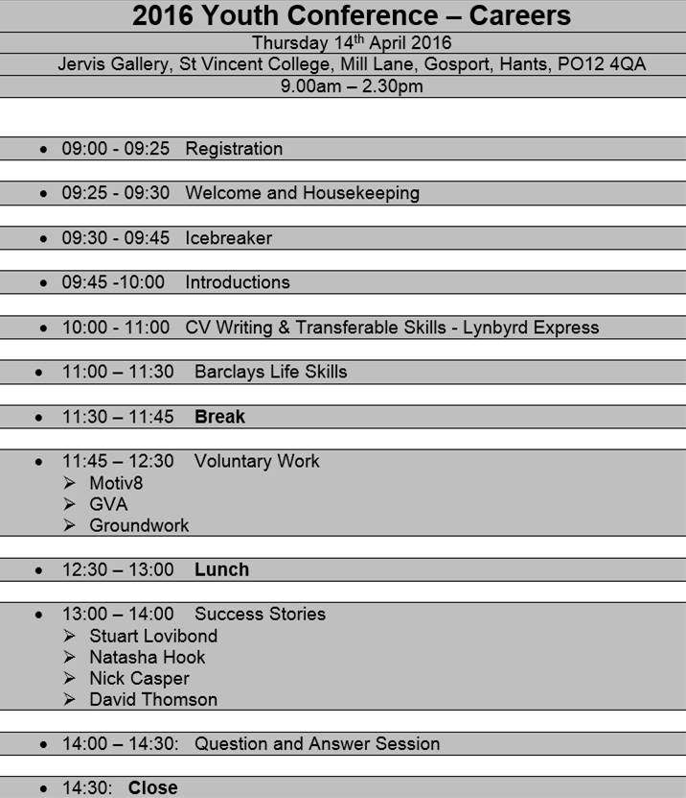

***Room layout and organisation***

Every attendee was allocated a table number. The same school students were seated together on each table. Each table also had a facilitator allocated by Gosport Youth Council to encourage students to engage with the conference and resolve any issues or confusions that may have occurred.

Every attendee was signed in at the conference reception desk by Gosport Youth Council members and allocated a St Vincent visitors sticker and a Gosport Youth Council name badge. The conference was attended by 71 young people and 30 adults.

There were 12 stalls around the room on the day for the attendees to speak to and find out information from, these stalls consisted of; Motiv8, National Citizen Service, Gosport Borough Football Academy, Fareham College, Gosport Voluntary Action, Bay House School and Sixth Form, Groundwork, Lynbyrd Express, Gosport Youth Council, Caroline Dinenage MP, St Vincent College and SL Guitar Lessons.

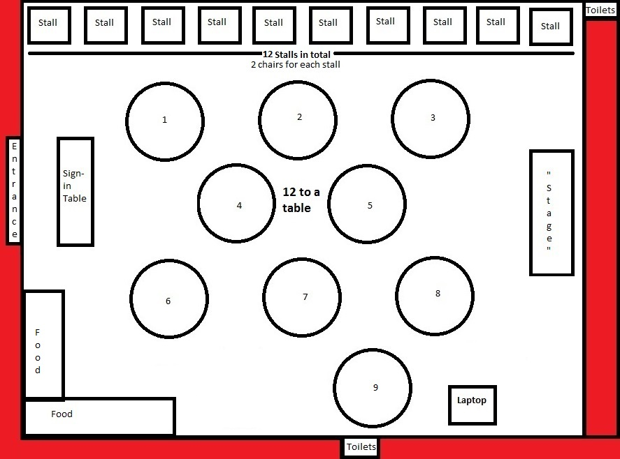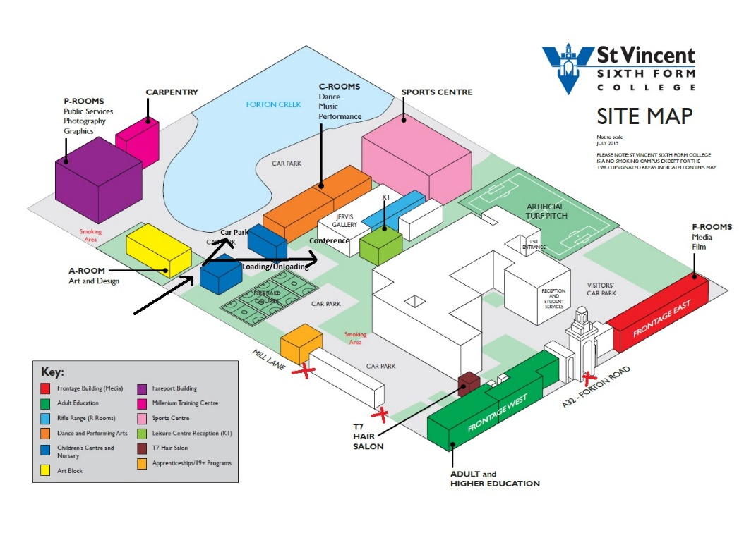

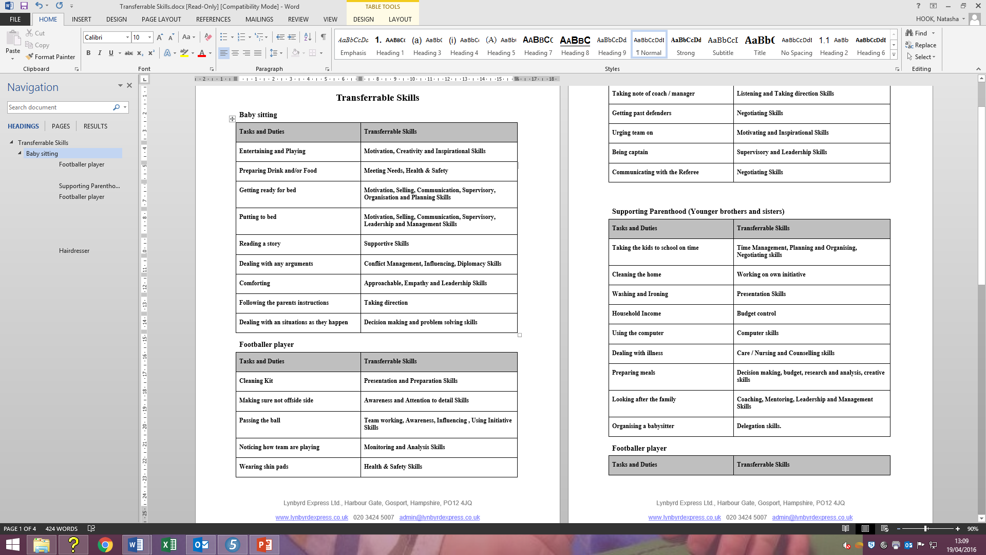***CV writing and Transferable Skills***

The first workshop was focused on CV writing and Transferable Skills and was hosted by Lynbyrd Express.

The aims of this session were to;

* have a better understanding of what makes a good CV
* be able to identify skills you already have
* know what terminology is going to best support job applications

Carly from Lynbyrd Express explained how employers use CV’s and the dos and don’ts when writing a CV.

She then discussed transferable skills and the attendees had group discussions on their tables to see what skills they already have, Carly visited each table to support and give further ideas.

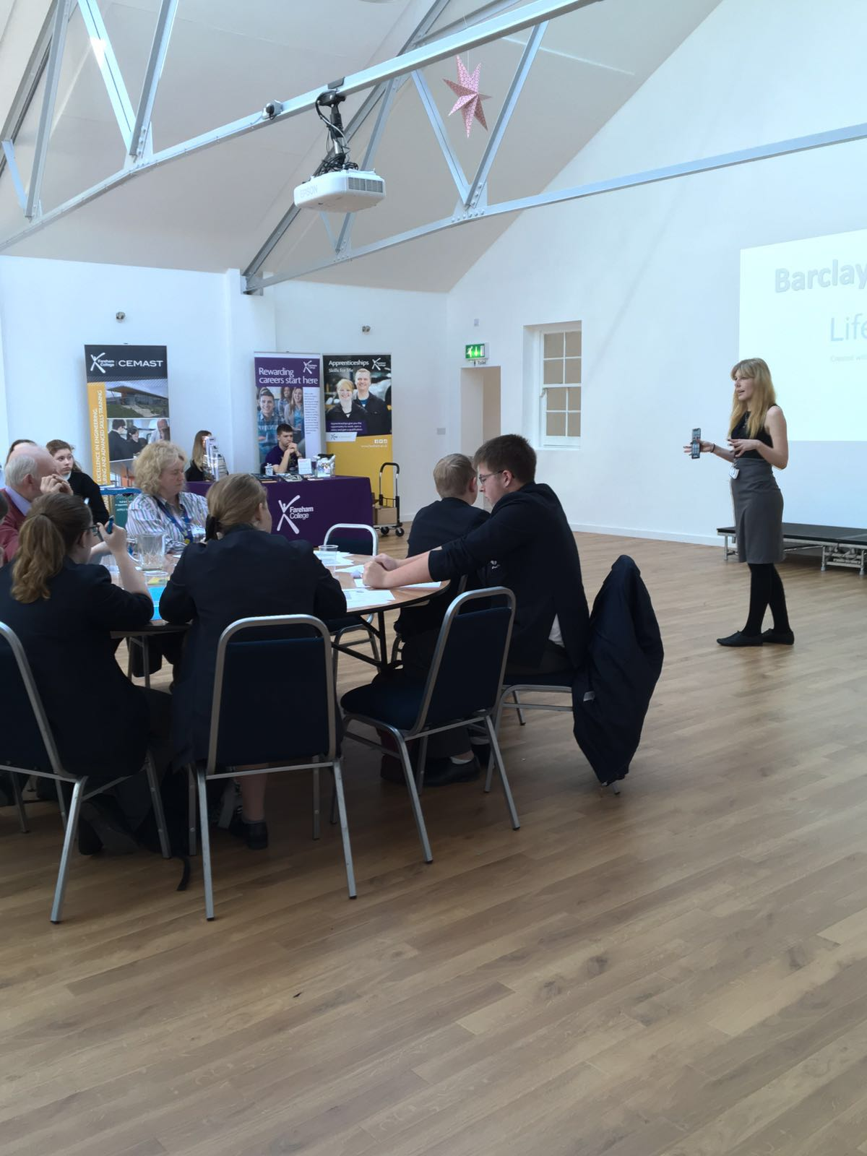***Barclays Life Skills***

The second workshop was based around Barclays Life Skills TV Adverts and was hosted by Natasha Hook.

The attendees watched 3 minutes of Barclays Life Skills TV Adverts surrounding Social Media and then had 15 minutes to discuss the following questions, write their views on large sheets of coloured paper and feedback as a group;

* What have you learned?
* Did you realise how social media can affect your career?
* Will you change the way you use social media?
* How important do you think social media is?

The attendees watched a further 3 minutes of Barclays Life Skills TV Adverts surrounding Persona and then had 15 minutes to discuss the following questions, write their views on large sheets of coloured paper and feedback as a group;

* What have you learned?
* Did you realise how your persona can affect your career?
* Will you change the way you approach interviews and companies?
* How important do you think your persona is?

***Voluntary Work***

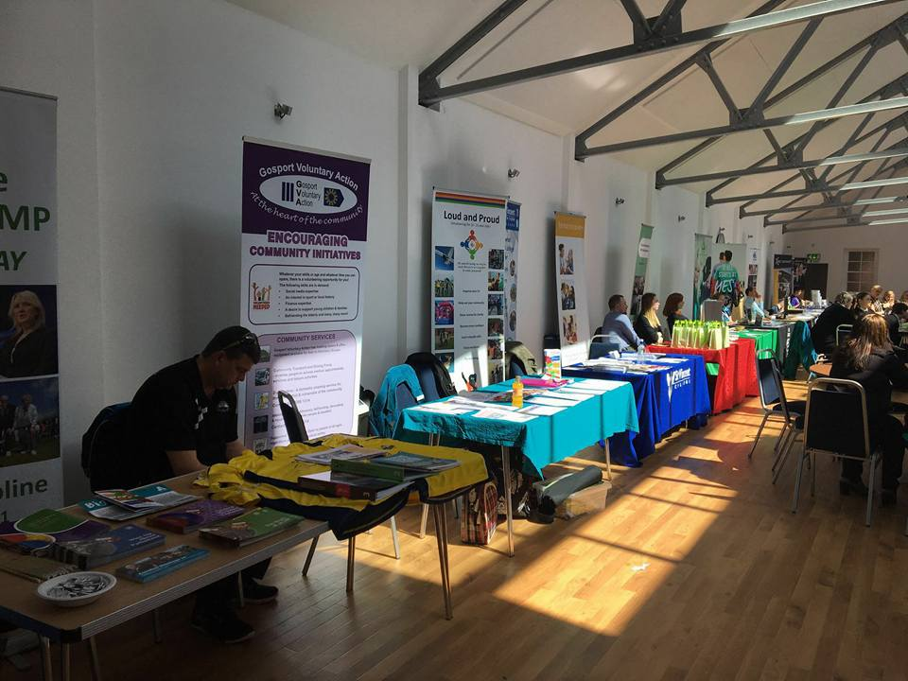The voluntary work workshop consisted of 3 local organisations who spoke about what their organisation does and what they can do for you. These organisations were; National Citizen Service, Gosport Voluntary Action and Groundwork.

**National Citizen Service**

National Citizen Service (NCS) is an experience for young people they really don't want to miss. For 15 to 17 years-old, this is a chance to embark on exhilarating challenges, make your mark and build skills for work and life. More than 200,000 young people have already said YES to NCS.

**Gosport Voluntary Action**

Gosport Voluntary Action (GVA) is an independent charity providing voluntary sector support, community development, domestic help, information, community transport services and a range of other services for the residents of the borough of Gosport.

**Groundwork**

Groundwork work towards a future of sustainable communities which are vibrant, healthy and safe, which respect the local and global environment and where individuals and enterprise can prosper.

***Success Stories***

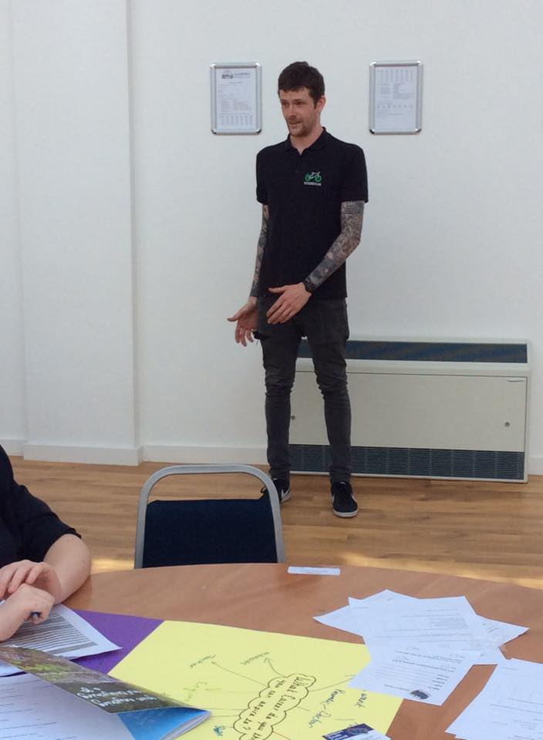The Success Stories workshop consisted of 4 local speakers; Stuart Lovibond, Natasha Hook, Nick Casper and David Thomson who spoke about their journey to get to their career today.

**Stuart Lovibond**

Working as a freelance guitarist Stuart has played various venues, parties, festivals and more. In 2010 working with young people is something that he discovered he was able to do – with and without a musical focus.

**Natasha Hook**

Natasha joined the Gosport Youth Council aged 11 and the work experience and skills from this has enabled her to now be working full time for Caroline Dinenage MP.

**Nick Casper**

Nick Casper is a bike mechanic who started work at Motiv8’s Bicycle Recycling as an apprentice.

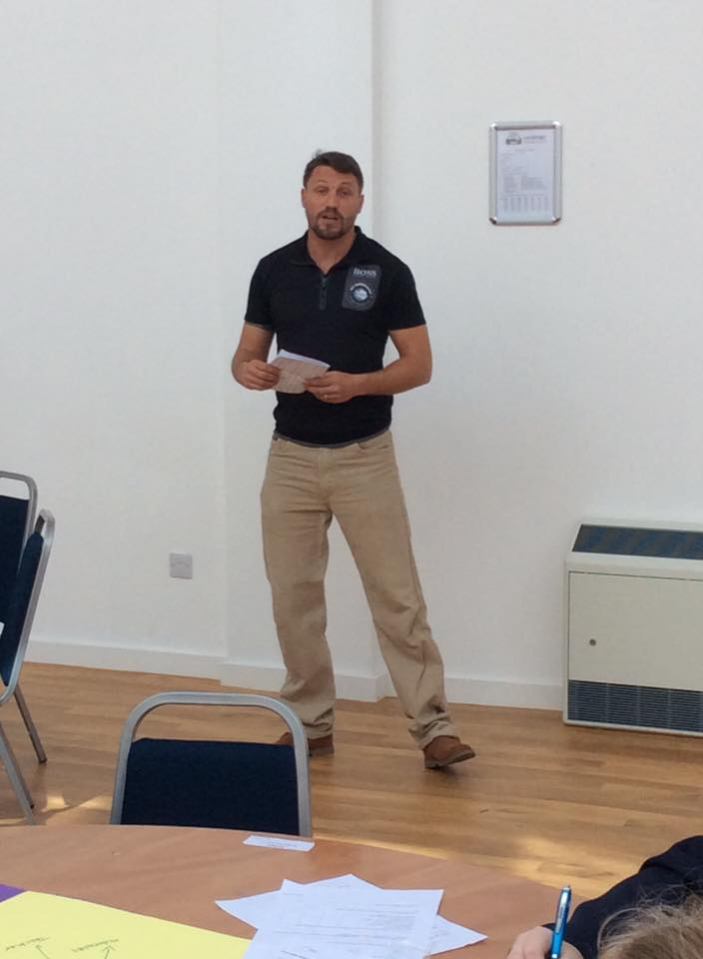**David Thomson**

David Thomson is one of the UK's most experienced sailors. Prior to achieving third place in the inaugural Global Ocean Race 2008-09, Thomson already had a rich sailing CV having crewed aboard the record-setting maxi-multihull PlayStation; raced extensively in the highly competitive South Coast fully-crewed circuit and worked as a senior preparateur and trusted team member for numerous solo round-the-world racing campaigns. Since his circumnavigation in the GOR 2008-09, Thomson has been an instrumental part of some diverse and high-profile projects including the ground-breaking trans-Pacific Plastiki Project while enhancing his Class40 racing experience in The Fastnet and Quebec-St Malo Race.

***Questions and Answer Session***

Questions were then asked to the four success stories speakers. Some of the questions asked were;

* What piece of advice would you give your 16 year old self now?
* What was your biggest achievement in your career?
* How did you find your passion?

***Other activities***

**Mapping Exercise**

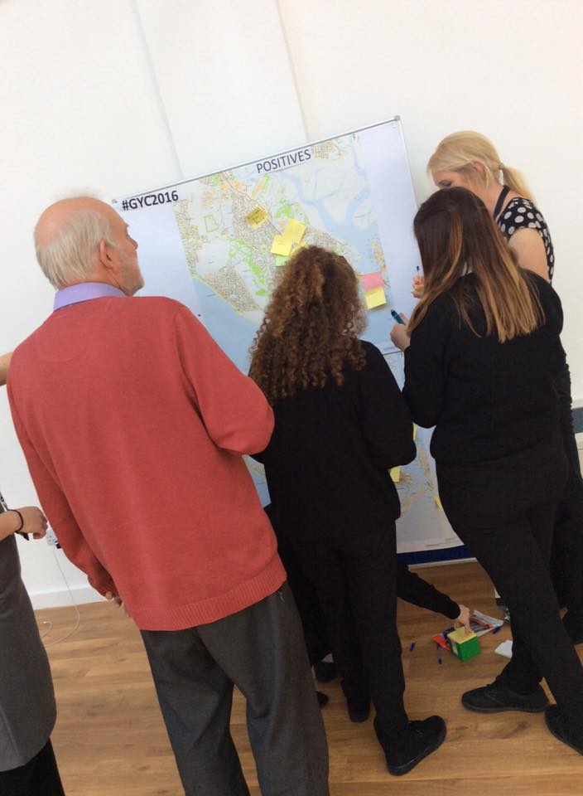Young people were given the opportunity to put post it notes on two maps of Gosport, one showing all of the positive things in Gosport and the other showing the negative things. Young people could annotate the maps with reasons why they liked or disliked a certain aspect of Gosport.

These views will help Gosport Youth Council to work on future projects and represent young people to the best of their ability and represent their views.

**Wall questions**

The following questions were up around the room so that we could gain a better understanding of the issues Gosport young people face as well as how aspirational the young people are.

* + Where do you get your careers advice from?
  + Who inspires you?
  + What career do you think you can aspire to?
  + What do you see yourself doing in 5 years’ time?
  + What is your biggest concern about the topic of careers?
  + If you could do one thing to improve Gosport, what would it be?

***Summary and Evaluation***

The Gosport Youth Council produced a feedback form which was given to every attendee to fill in at the end of the day. Attendees were also given contact forms and “Gosport Youth Council – We want you views” surveys.

***Conclusion and Recommendations***

The Gosport Youth Council 2016 Careers Conference received positive feedback from both students and adults.

Following from the feedback forms and surveys;

* Nearly 2/3 of the attendees believe there should be an annual Youth Conference therefore it is recommended to ensure engagement with young people remains that a Youth Conference should be held annually.
* Of all the subjects put forward Bullying and Crime are still the top issues for Young People in Gosport therefore it is recommended the next annual conference should be held on one of these topics.
* The venue was well liked, however the lack of a sound system and microphone created problems on the day, therefore it is recommended to ensure a microphone and sound system are available for use.
* The heat of the building became an issue later on in the day therefore it is recommended to either change venue or use it during a colder time of year.
* There were comments to make the workshops more interactive therefore it is recommended to create more interactive workshops for the next conference.
* The Success Stories was the highest rated workshop of the conference therefore it is recommended to include motivational speakers on the topic of the conference. The video presentation by David Thomson was well received and it is recommended wherever possible to use visual aids as part of the presentation to make it more interesting if possible

Following from GYC personal observations;

* Due to an issue with handouts for Workshop 1 the sessions under ran by 30 minutes. We were, however, able to have a 10 minute break and overrun the next workshop to get the schedule back on track therefore it is recommended that we double check with workshop hosts that everything is in place the day before and that the timings are as accurate as possible.
* There was a technical issue of no sound before workshop 2 which required sound, luckily a stall holder was on hand who had an amp which we could use therefore it is recommended we do a confirmation check with the venue the previous day.
* The lunch arrived on time however the session finished ten minutes earlier than expected. For future conferences we should endeavour to have lunch delivered 30 minutes prior to the end of the session
* If we are to use the Jervis Gallery again the stalls to be set out in an area away from direct sunlight as we were made aware of the heat.

***Appendices***

***Mapping Exercise***

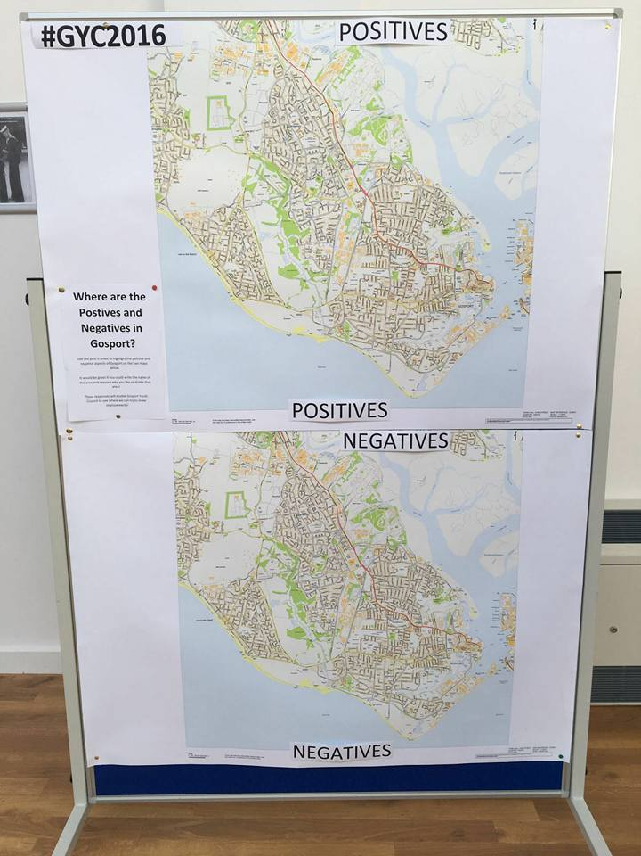

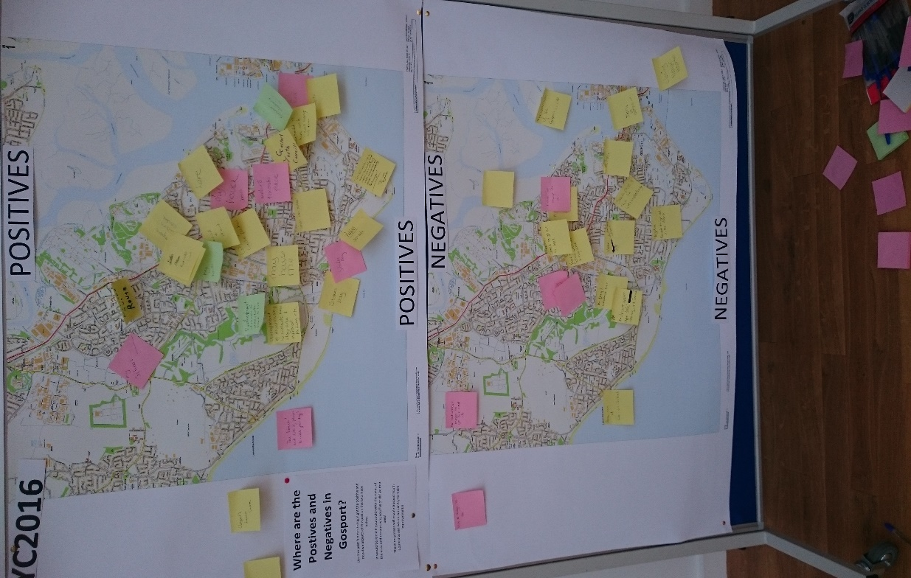

***Positives***

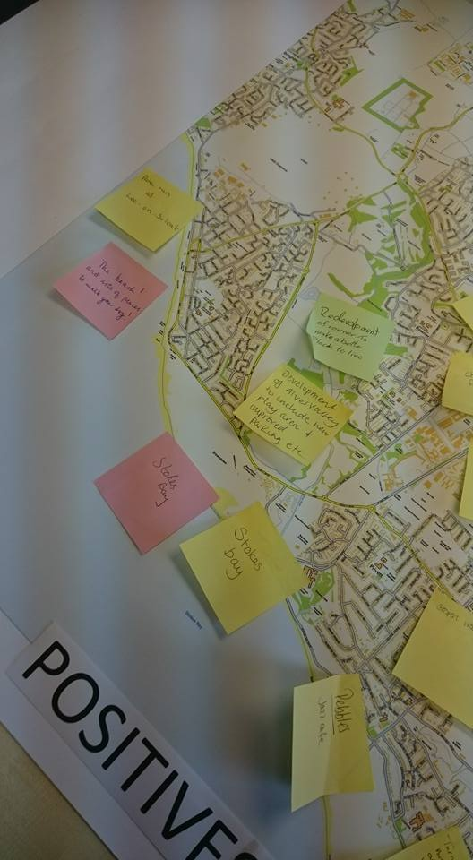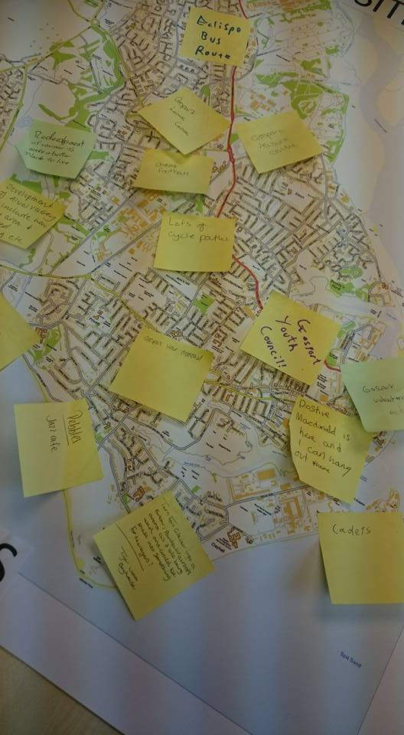

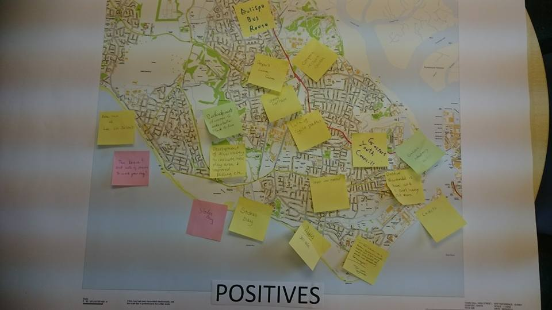

The following were listed as Positives in Gosport;

* Park run at Lee-on-Solent
* The beach!
* Lots of places to walk your dog
* Stokes Bay x2!
* Development of Alver Valley to include new play area
* Redevelopment of Rowner to make it a better place to live
* Pebbles – Jazz Café
* Eclipse Bus Route
* Gosport Leisure Centre x2
* Cheap Football (Gosport Leisure Centre)
* Badminton Courts (Gosport Leisure Centre)
* Lots of cycle paths
* Gosport Youth Council
* Gosport Voluntary Action
* Cadets
* McDonalds in Gosport High Street
* Gosport War Memorial
* Motiv8

***Negatives***

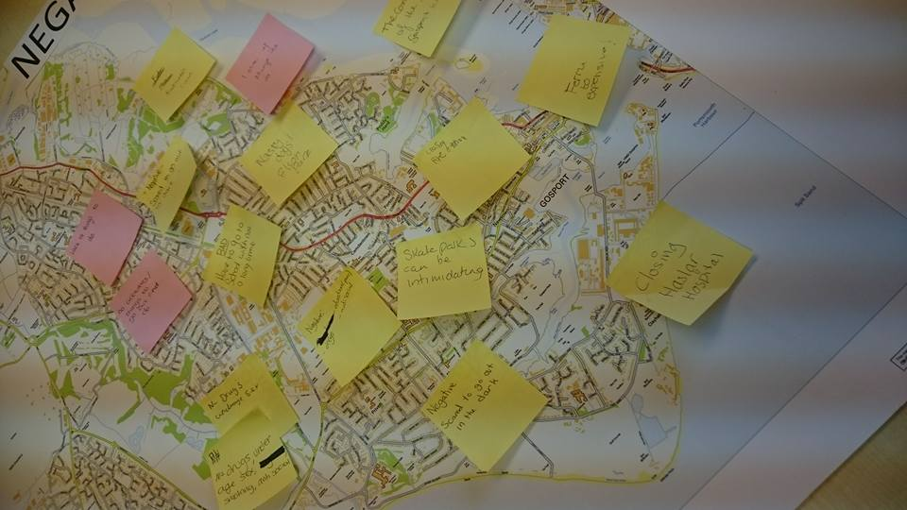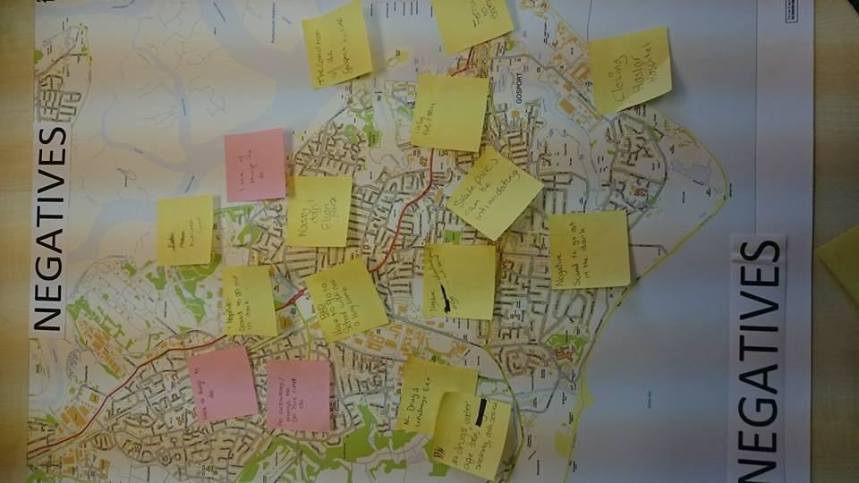

The following were listed as Negatives in Gosport;

* Turn Fort Gilkicker into a parkour, paintball and airsoft arena as it isn’t being used and could be made into something for teenagers!
* Lack of things to do x2
* Scared to go out in the dark x2
* No activities/things to go out and do
* Drugs x3
* Underage Sex x2
* Underage Smoking
* Anti-Social behaviour x2
* Poor education x2
* Nasty dogs at Elson Park
* Fire Station closing
* Skate Parks can be intimidating
* Closing Haslar Hospital
* Ferry too expensive
* The condition of Gosport Ice Rink

***CV Writing and Transferable Skills***

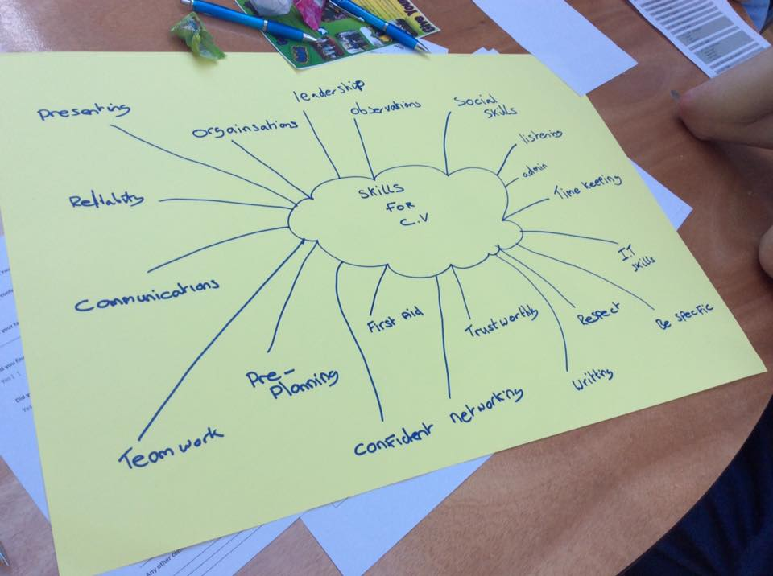

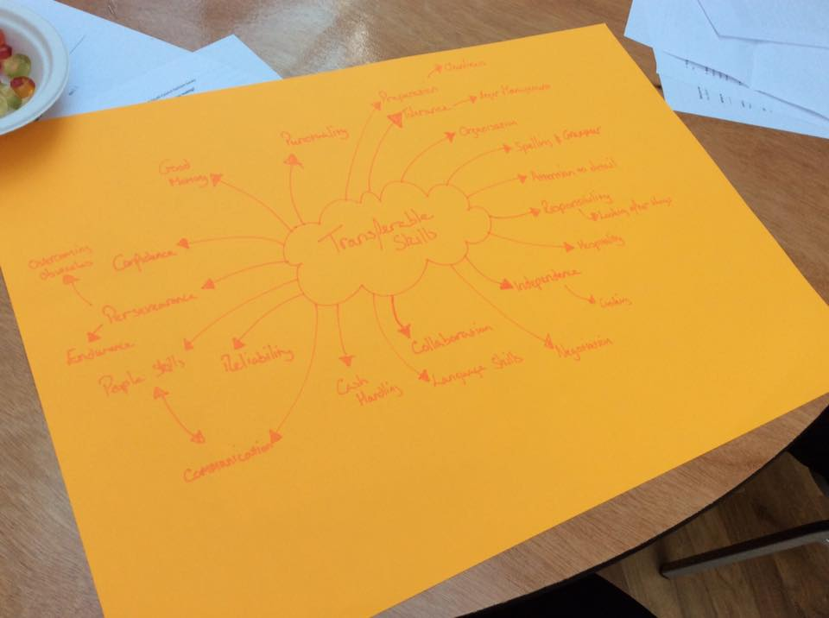

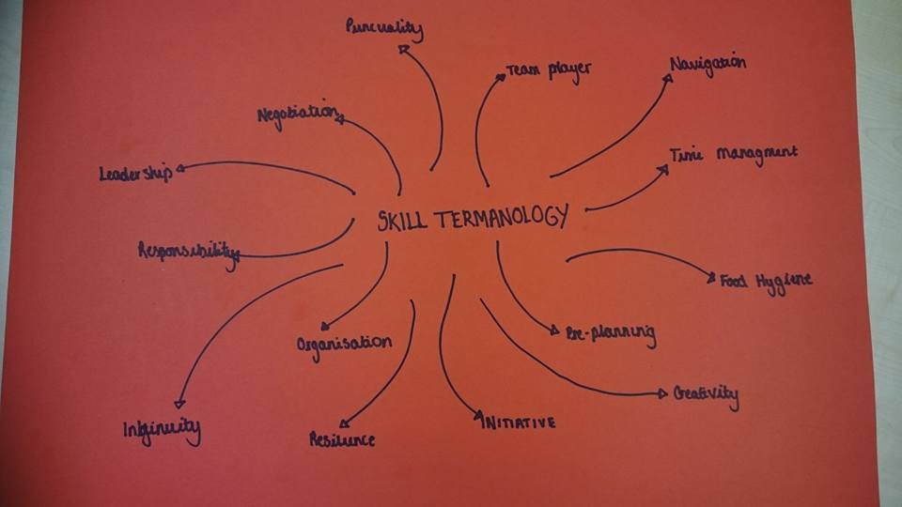

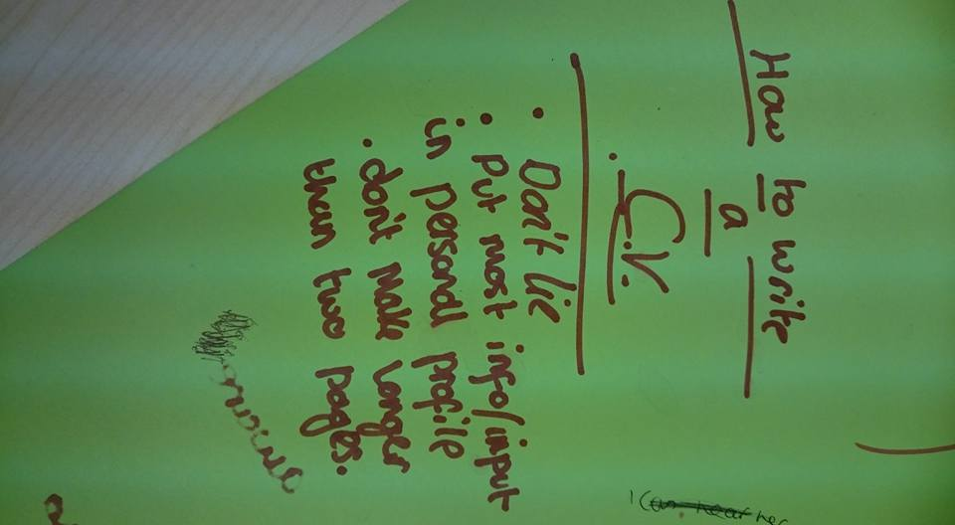

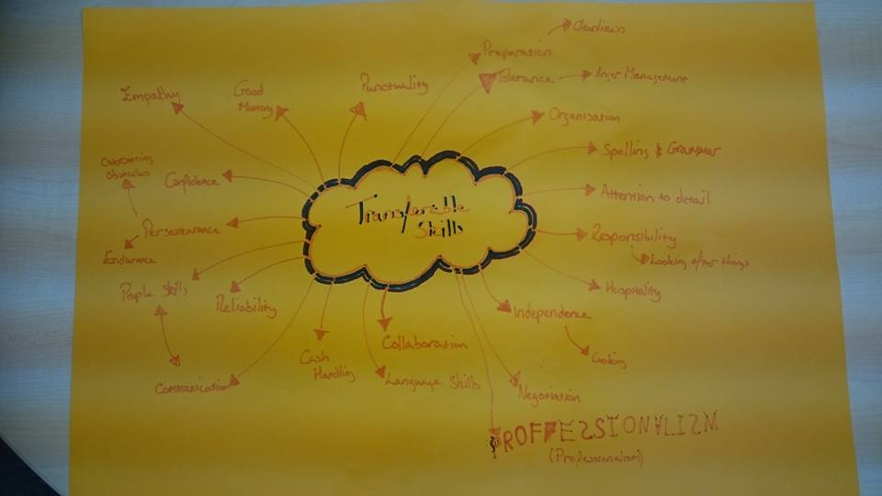

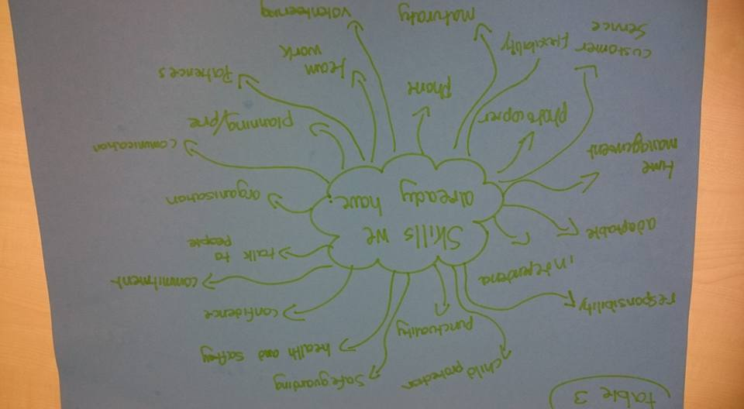

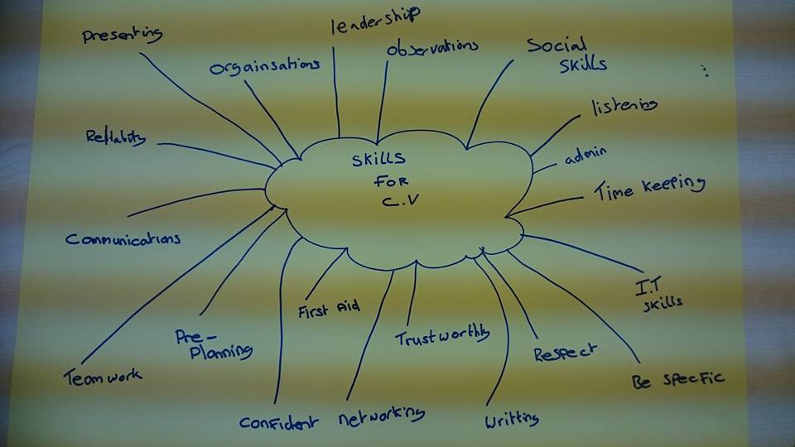

***Barclays Life Skill responses***

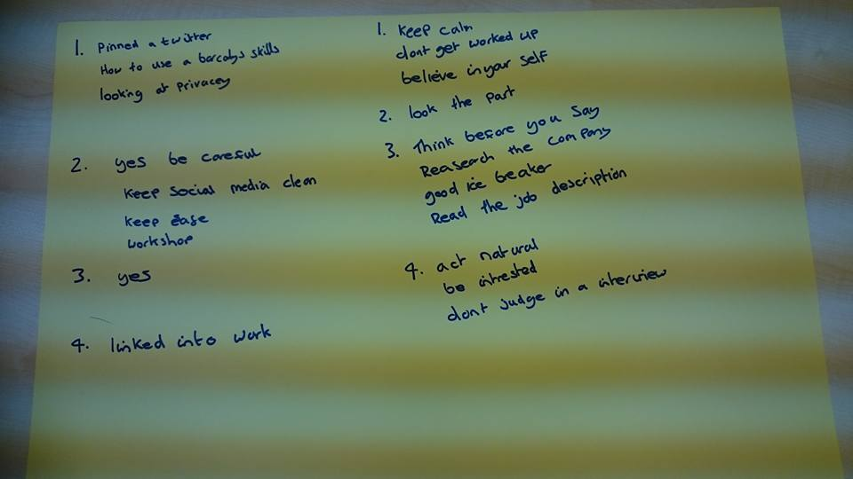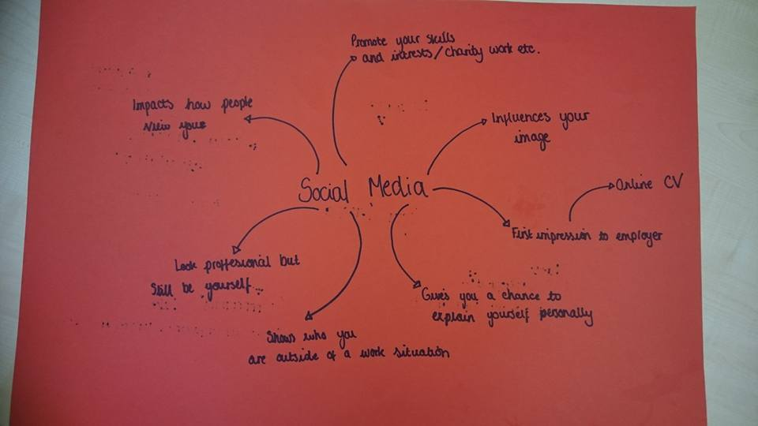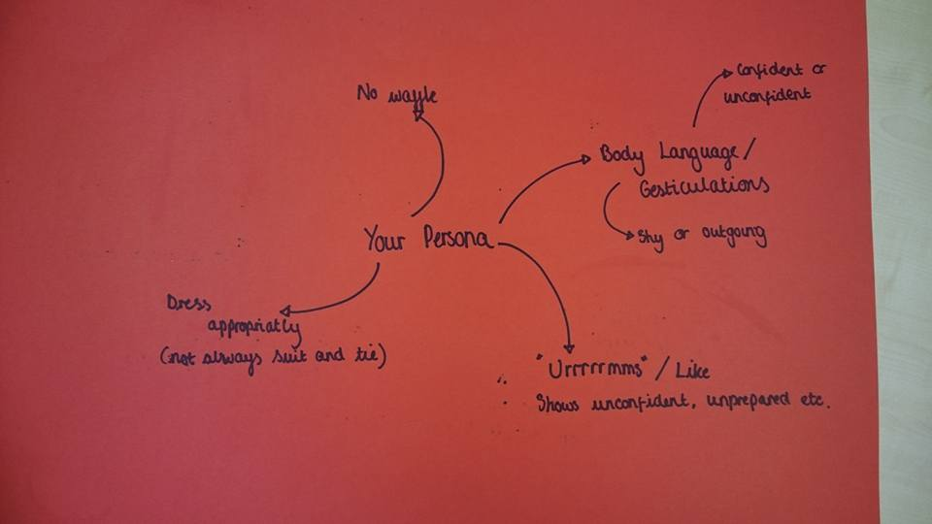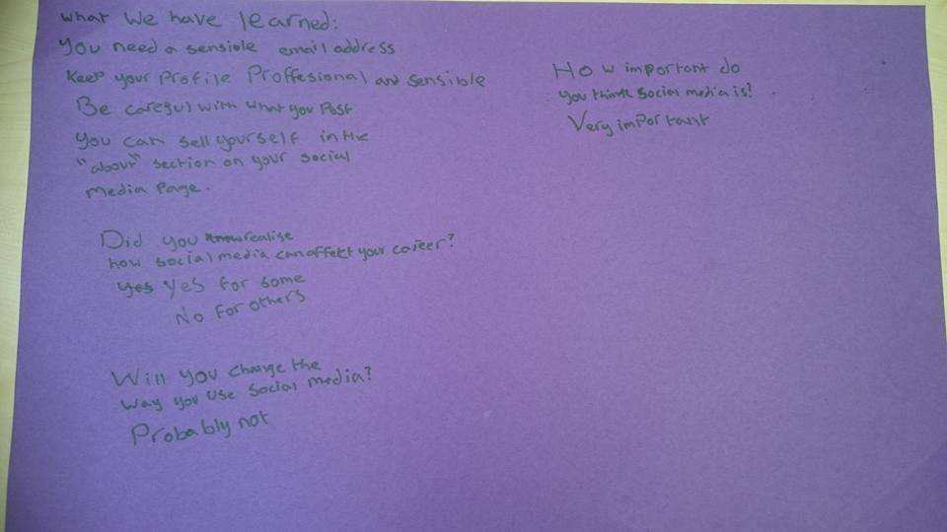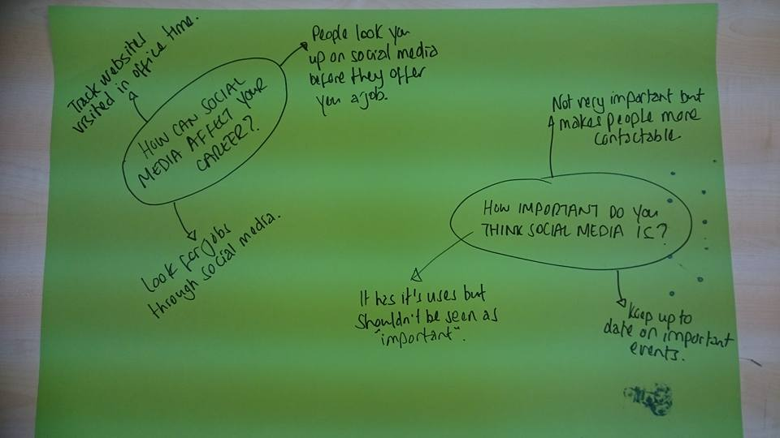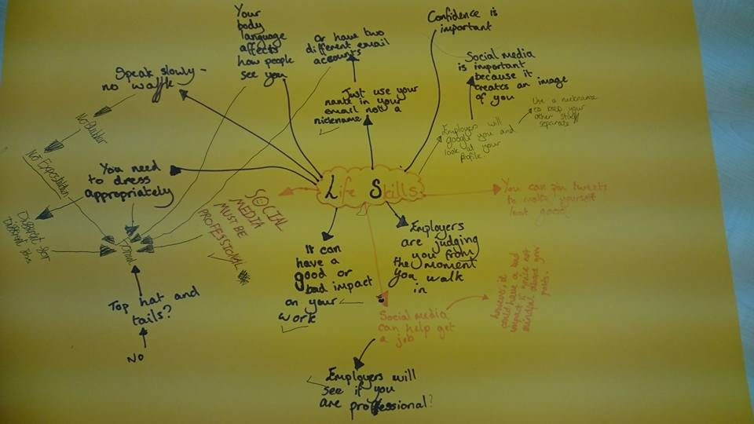

***Wall questions***

**Where do you get your careers advice from?**

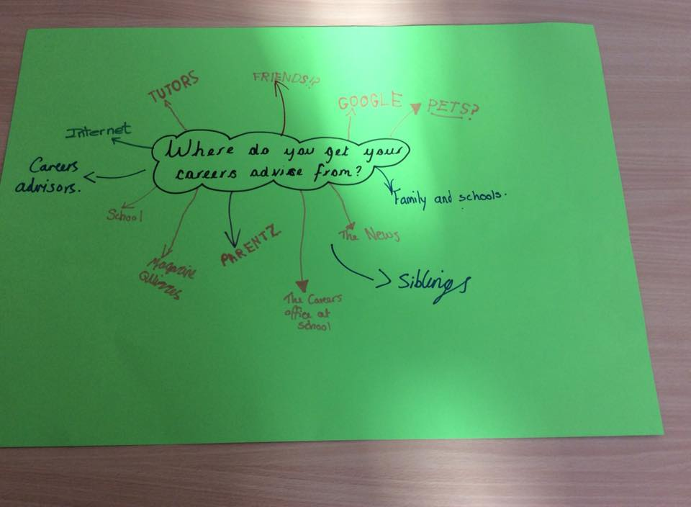

**Who inspires you?**

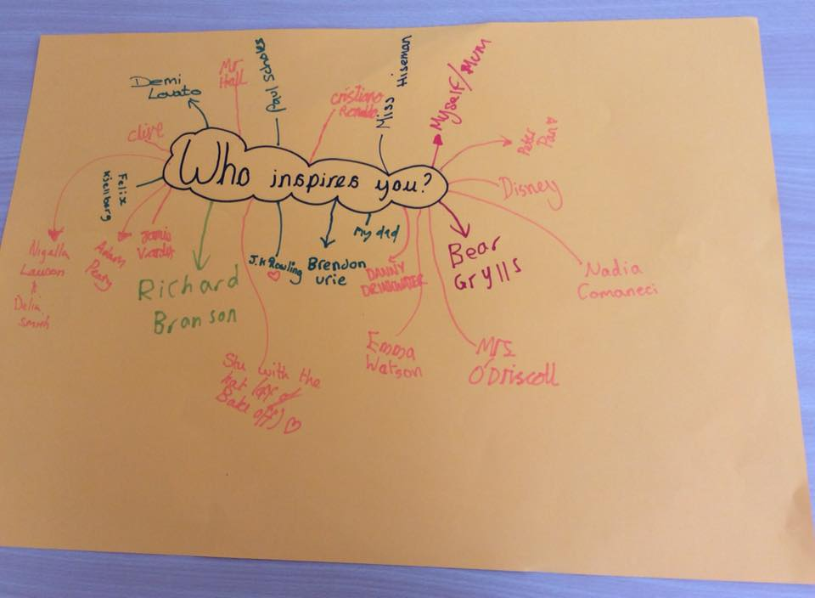

**What career do you think you can aspire to?**

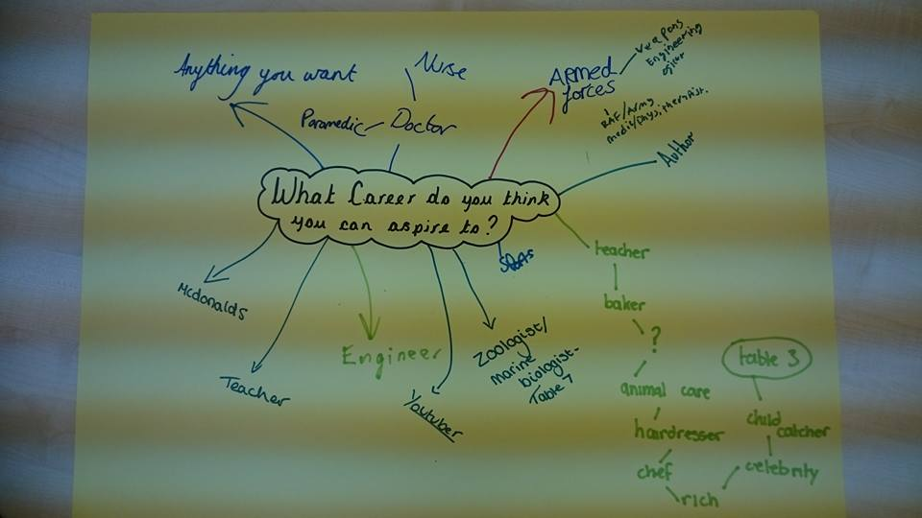

**What do you see yourself doing in 5 years’ time?**

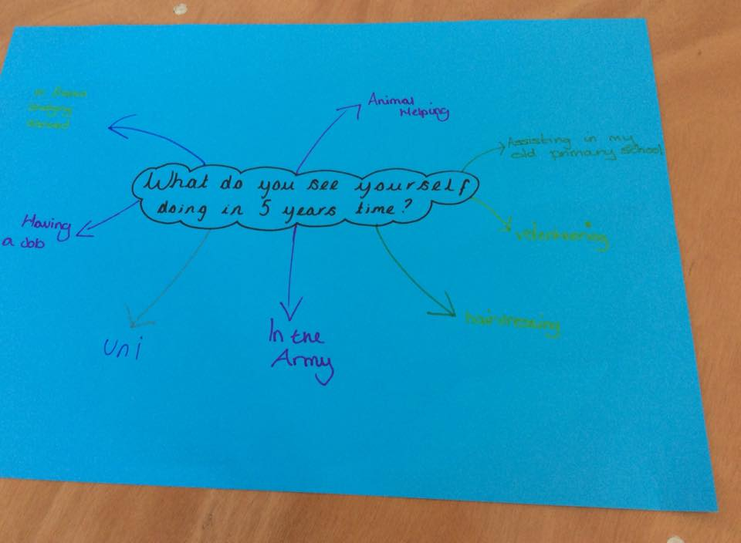

**What is your biggest concern about the topic of careers?**

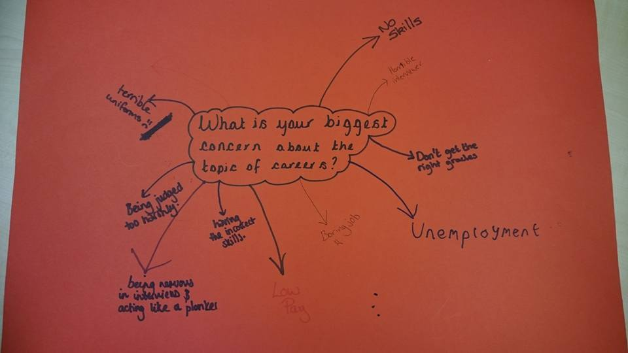

**If you could do one thing to improve Gosport, what would it be?**

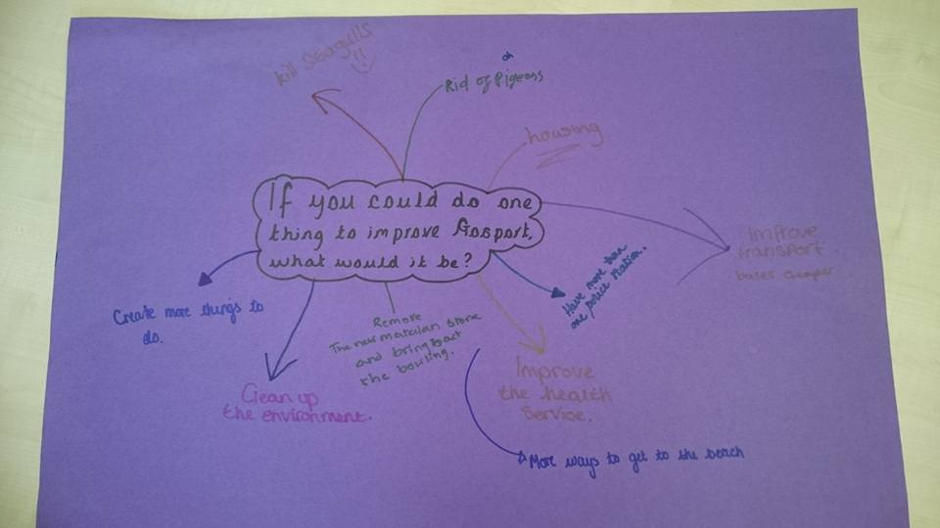

***Feedback Results***

***Any other comments***

I think there should have been more local colleges, such as South Downs or Highbury stalls at the event

More interactive workshops

Different range of things

Needed a microphone

Venue too hot and conference too long

Venue too hot

Make the workshops more interactive

I would have enjoyed the day more if there was an animal care college

Have a speaker who enjoyed school, great speakers but similar pathways

I would of enjoyed it more if there were an ?? Stall

Needed microphone

It was a successful day

It was a good day for the students. They enjoyed the speakers at the end!

Well done to the young people who announced the programme. A microphone would have helped. Venue too hot

***Survey Results***

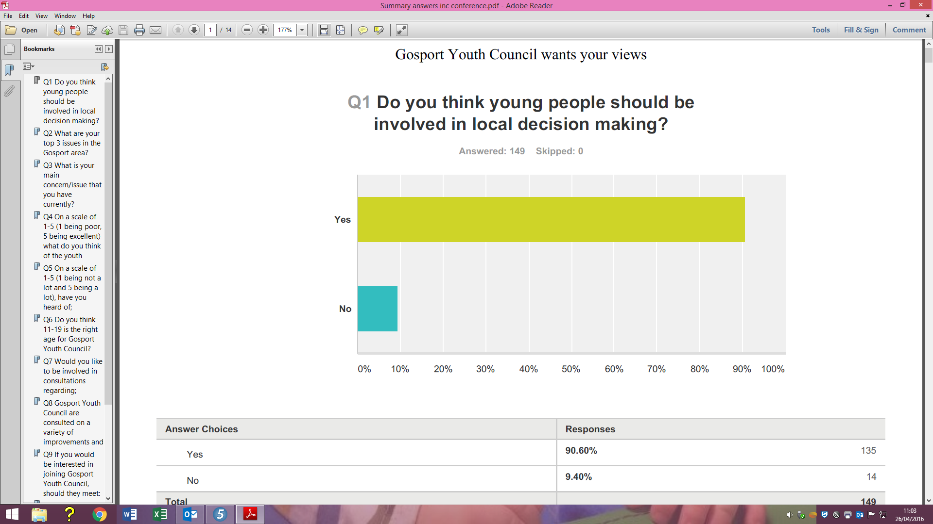

90% of people surveyed at both the Youth Conference and in December 2015 believe that Young People should be involved in local decision making – this is a rise from 87% in just the first survey December 2015.

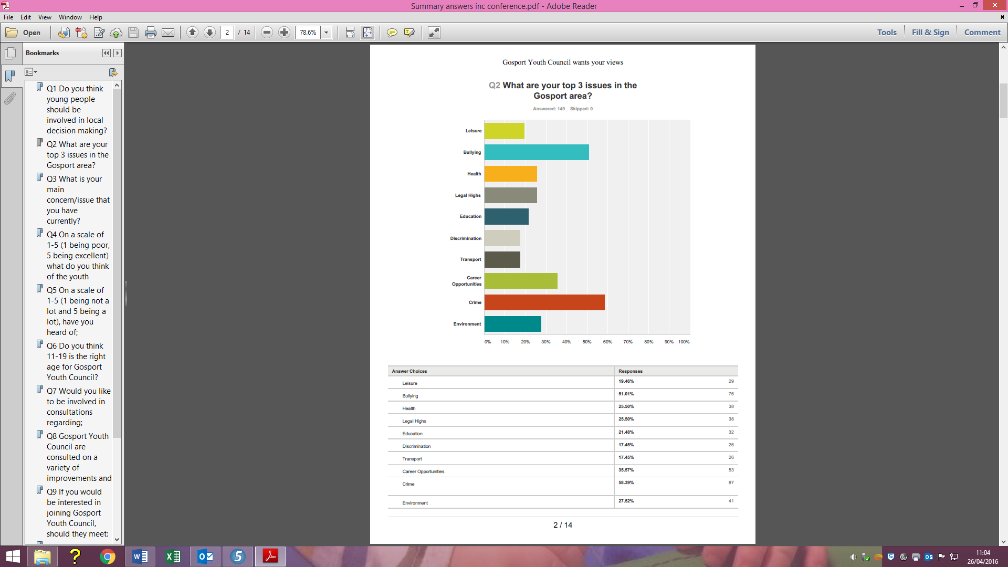

The top three issues have remained the same since December 2015; Crime, Bullying and Career Opportunities.

|  |  |  |
| --- | --- | --- |
| **Ranking** | **Dec 2015** | **April 2016** |
| 1 | Crime (60%) | Crime (58%) |
| 2 | Bullying (50%) | Bullying (51%) |
| 3 | Career Opportunities (36%) | Career Opportunities (36%) |
| 4 | Environment (31%) | Environment (28%) |
| 5 | Legal Highs (26%) | Health and Legal Highs (26%) |
| 6 | Health (21%) | Education (21%) |
| 7 | Leisure (20%) | Leisure (19%) |
| 8 | Education (19%) | Discrimination and Transport (17%) |
| 9 | Discrimination (18%) |  |
| 10 | Transport (17%) |  |

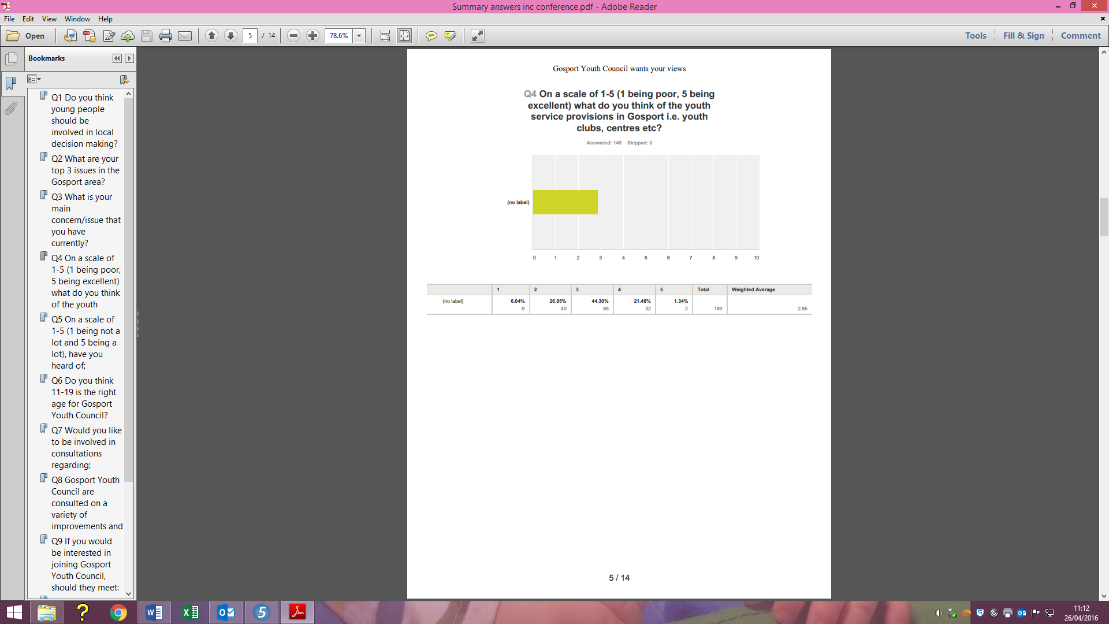

The weighted average rose from 2.66 in December 2015 to 2.85 in April 2016.

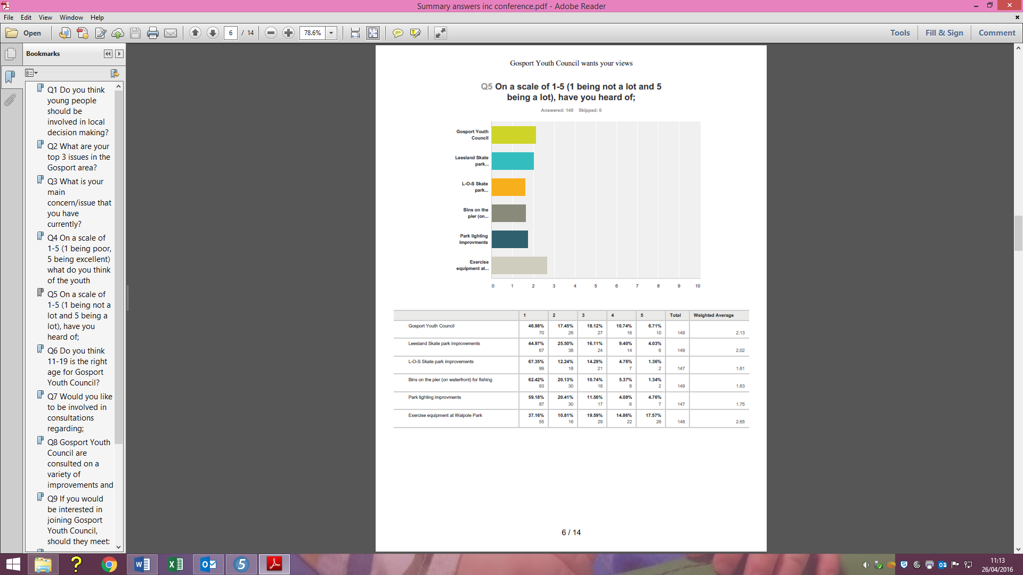

|  |  |  |
| --- | --- | --- |
|  | Weighted Average Dec 15 | Weighted Average Apr 16 |
| Gosport Youth Council | 2.10 | 2.13 |
| Leesland Skate Park | 1.97 | 2.02 |
| L O S Skate Park | 1.48 | 1.61 |
| Bins on the pier | 1.56 | 1.63 |
| Park lighting improvements | 1.58 | 1.75 |
| Walpole Park equipment | 2.65 | 2.65 |

The weighted average for each of the above projects has either increased or remained the same between December 2015 and April 2016.

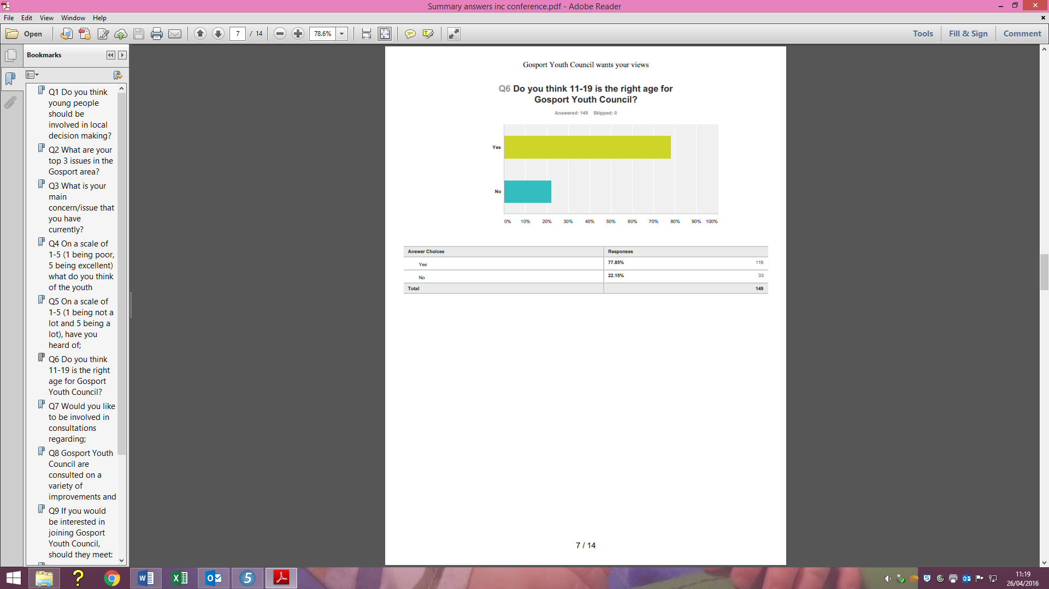

78% of respondents believed that 11-19 is the right age for GYC in April 2016 compared to 76% in December 2015.

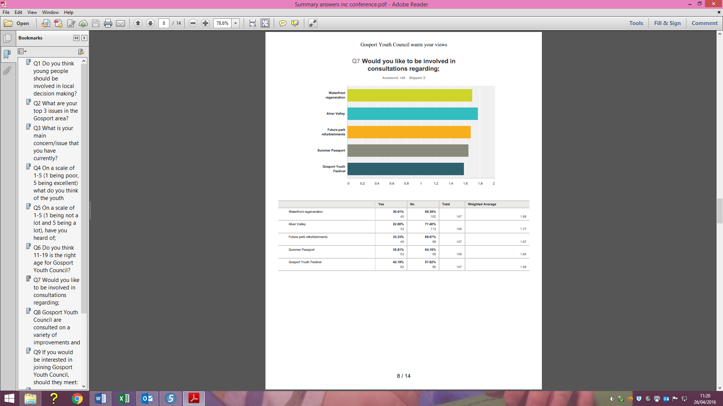

|  |  |  |
| --- | --- | --- |
|  | Yes December 2015 | Yes April 2016 |
| Waterfront Regeneration | 35% | 31% |
| Alver Valley | 23% | 22% |
| Park refurbishments | 39% | 33% |
| Summer Passport | 35% | 35% |
| Gosport Youth Festival | 47% | 42% |

Unfortunately the number of respondents who wanted to be involved in consultations remained the same of decreased in the data from the April 2016 survey.

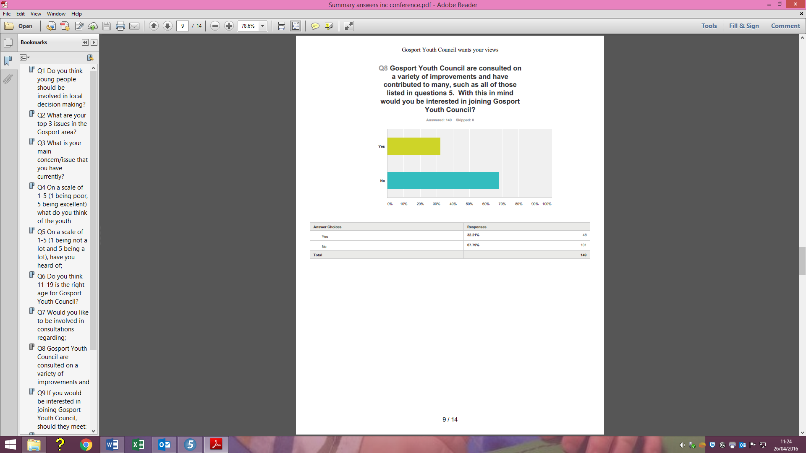

However 32% of people were interested in joining Gosport Youth Council up from 30% in the December 2015 survey.

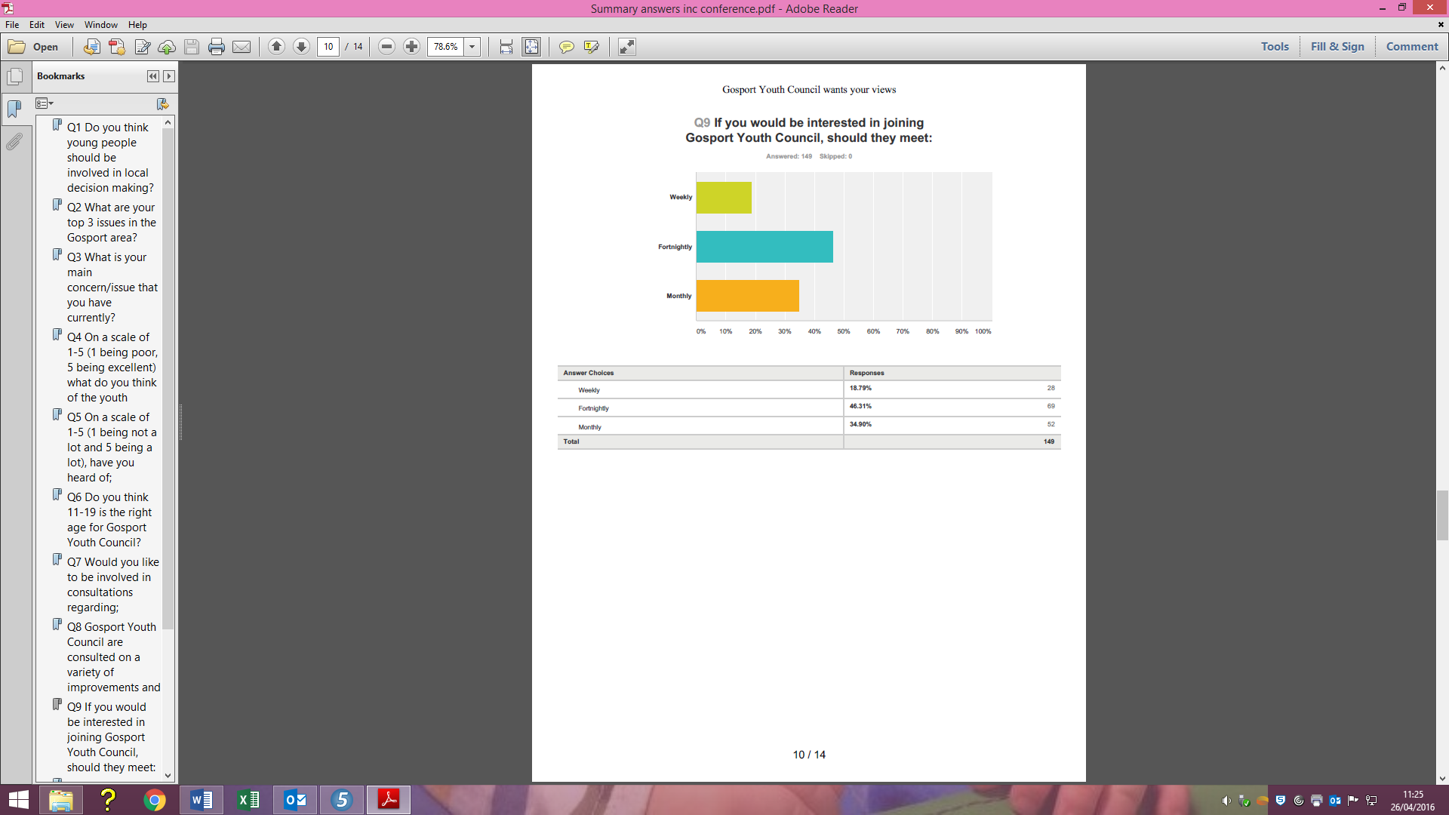

47% of people believe meetings should be held weekly with the percentage rising from 43% in the December 2015 survey. The percentage for monthly meetings also rose from 32% to 35% whereas weekly meetings dropped from 25% to 19%.

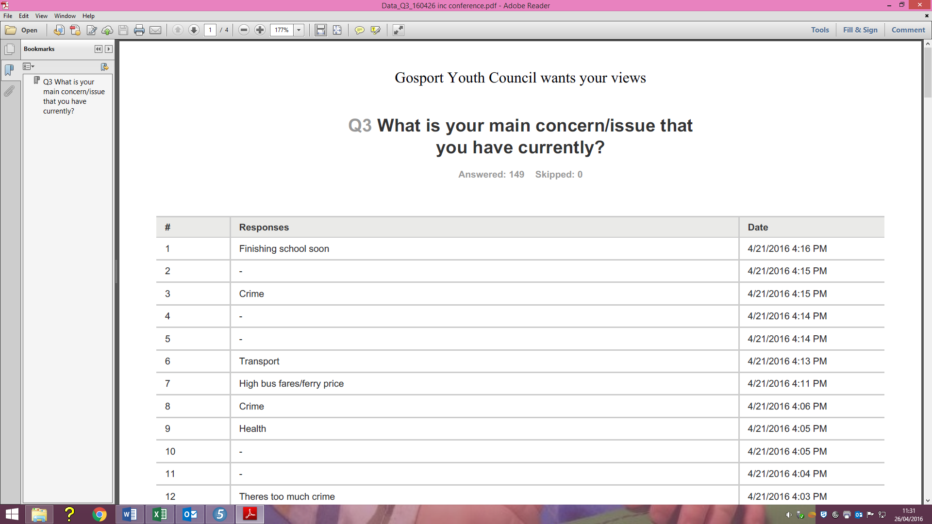April 2016

|  |  |
| --- | --- |
| Comment | Number |
| Crime | 9 |
| Health | 4 |
| Things to do | 4 |
| Anti-Social Behaviour | 3 |
| Bullying | 3 |
| Discrimination | 2 |
| My Education | 2 |
| Transport | 2 |
| Lack of Jobs | 1 |

December 2015

Bullying 11

Police/Crime 11

Career Opportunities 11

Safety 7

Transport 7

Education 5

Litter 3

Environment 3

Leisure 3

Drugs 3

Legal Highs 2

Health 2

Roads 1

Discrimination 1

Gosport High Street 1